**Introduction to C# Programming and Unity**

**Week1: -**

*First Console App in VS*

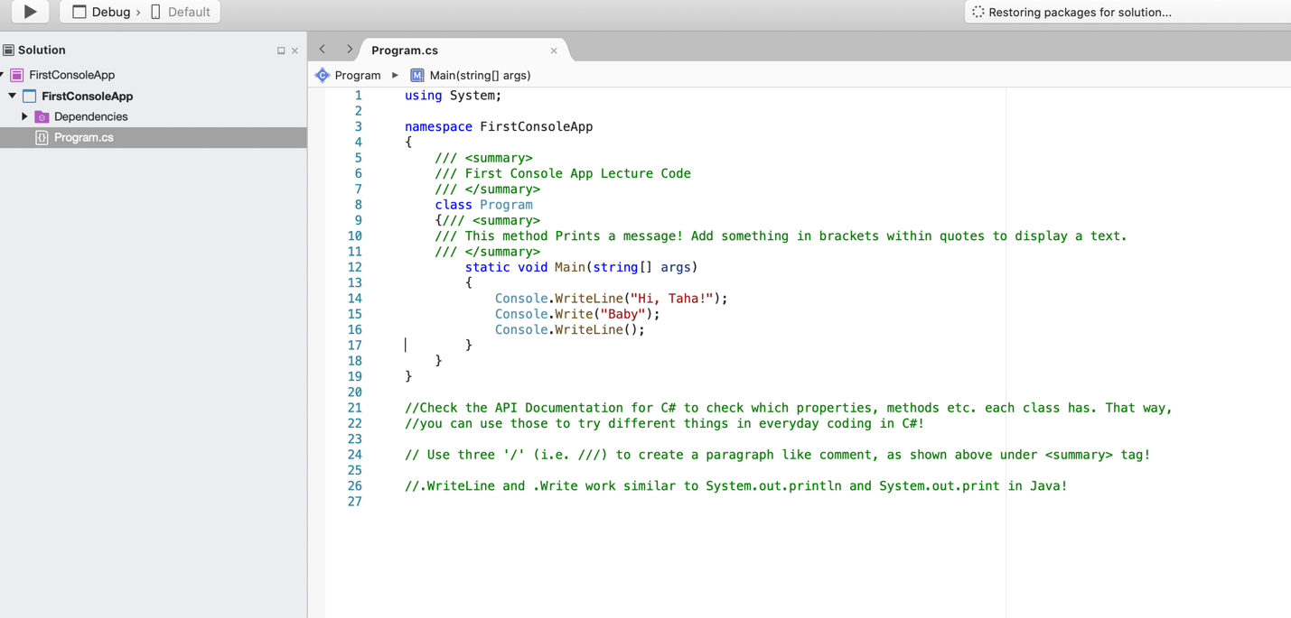

*First Unity Script*

Go to Layout in the corner and select “Starting Layout”.

* Create a script folder in assets. Create a C# file by right click and name the file PrintMessage. PrintMessage file will already have a start() method that is called before the first frame update. It also has an update() method that is called once per frame! This file is not like the usual C# file with string args[], but looks a lil different.
* Rename sceneSample with scene0 or something else because we may need to create many scenes later.
* For now, delete update() method because we don’t need it.
* In Unity, we do not use console.inline, but rather we use print(“Hello”);
* Drag PrintMessage from Script to Main Camera object in scene0 inside Hierarchy and then run, using the arrow on top of Unity. You will see the message printed in the console.

Example code from ExerciseTwo

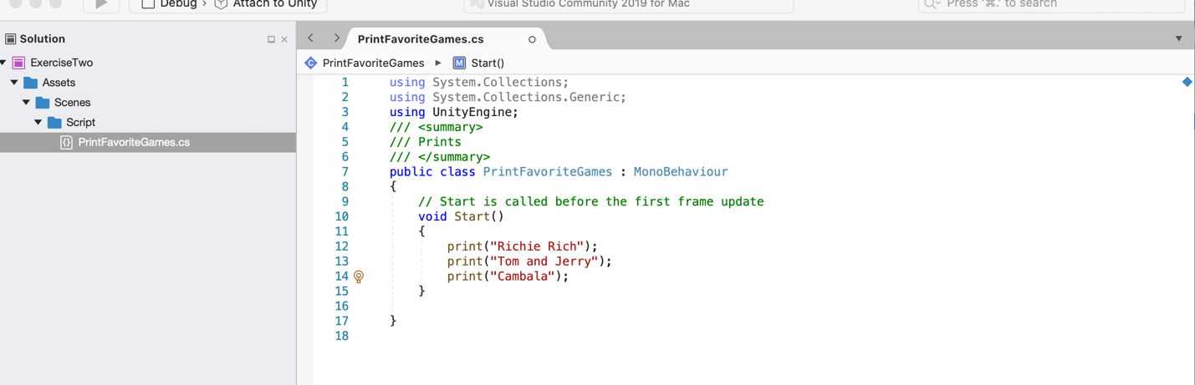

*Bits and Bytes*

* 1s and 0s
* There's a general mathematical equation that tells us, if we have b bits,

how many things can we represent?

* And that equation is 2 raised to the power of b equal n. 2^b = n. eg if we need to represent 4 people, we will need 4 sets of 2-2 each bits, 00,01,10,11.

*Data Types, Variables and Constants*

* Data/Variable is stored in memory in the form of 1s and 0s
* Data/Variable can have types
* We declare a variable to allocate it in a memory location.
* We can provide a value to a variable as well.
* For constants, when we declare them, we provide the data type, the constant name and the value
* Variable values can be changed as we run our program, but constants’ values can’t be changed.

*Integer Data Types*

* Types : byte, short, int, long, we will mostly use int
* So the difference between those data types is the number of

bits we use to represent those data types in memory.

So byte uses 8 bits, and short uses 16.

Int uses 32, and long uses 64.

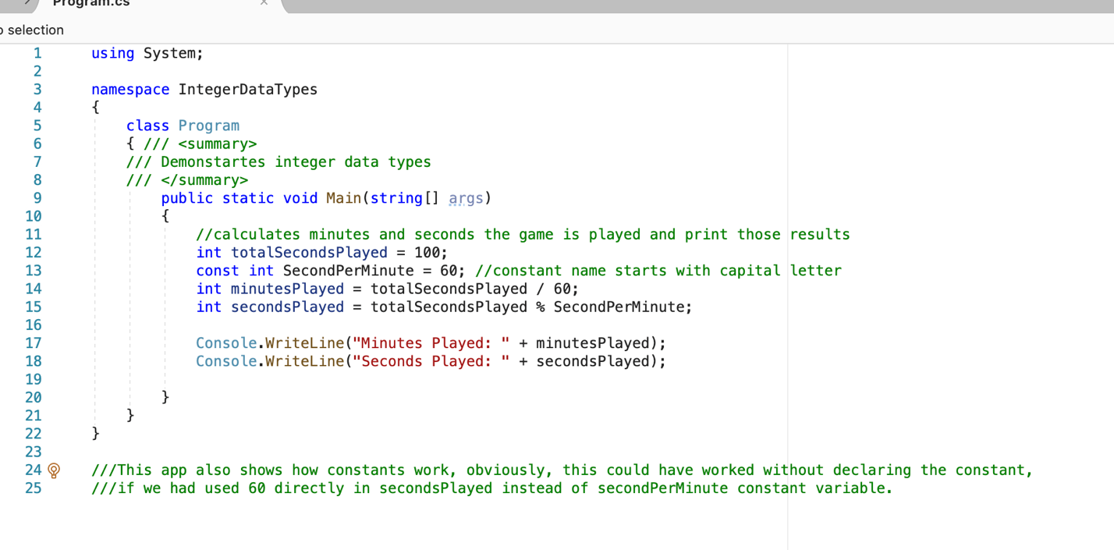

*Asking for user input example: -*

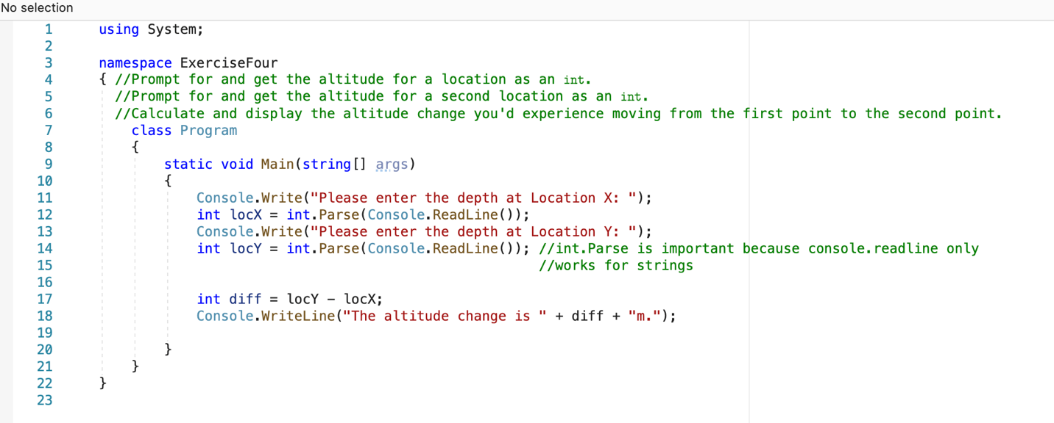

*Floating Data Types: -*

* Common types: float, double.
* The difference between float and double is

the number of bits used to represent those data types.

We get twice as many bits for doubles as we do for float.

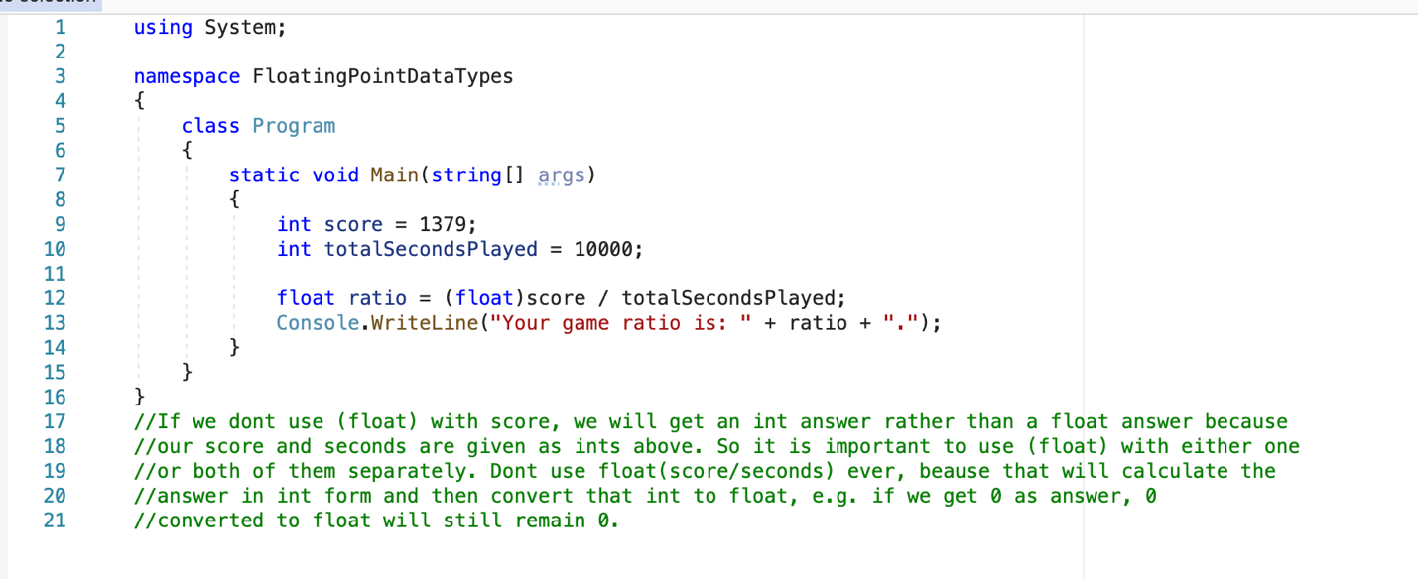

*Reading Documentation*

* Documentation can be accessed at <https://docs.microsoft.com/en-us/>
* We may need to look up API documentation several times for newly asked problems, such as in the examples below;

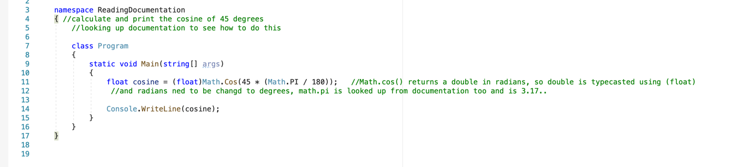

*45 was converted in radians as math.cos only accept radian in parameter*

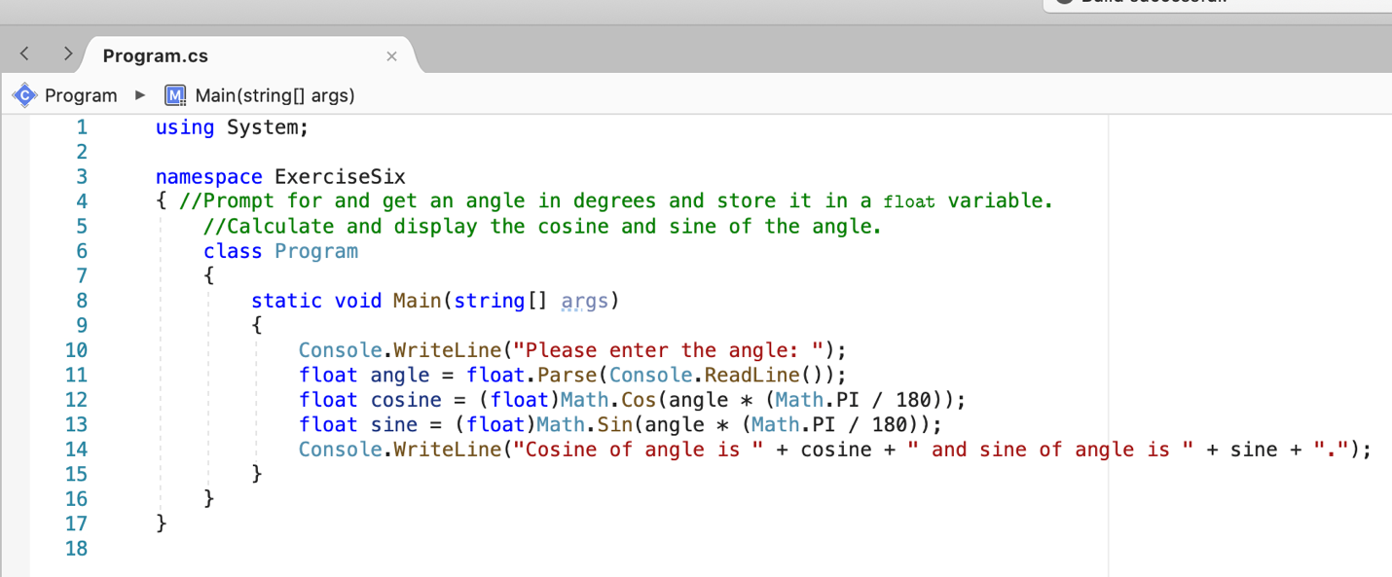

*Programming Assignment 1*

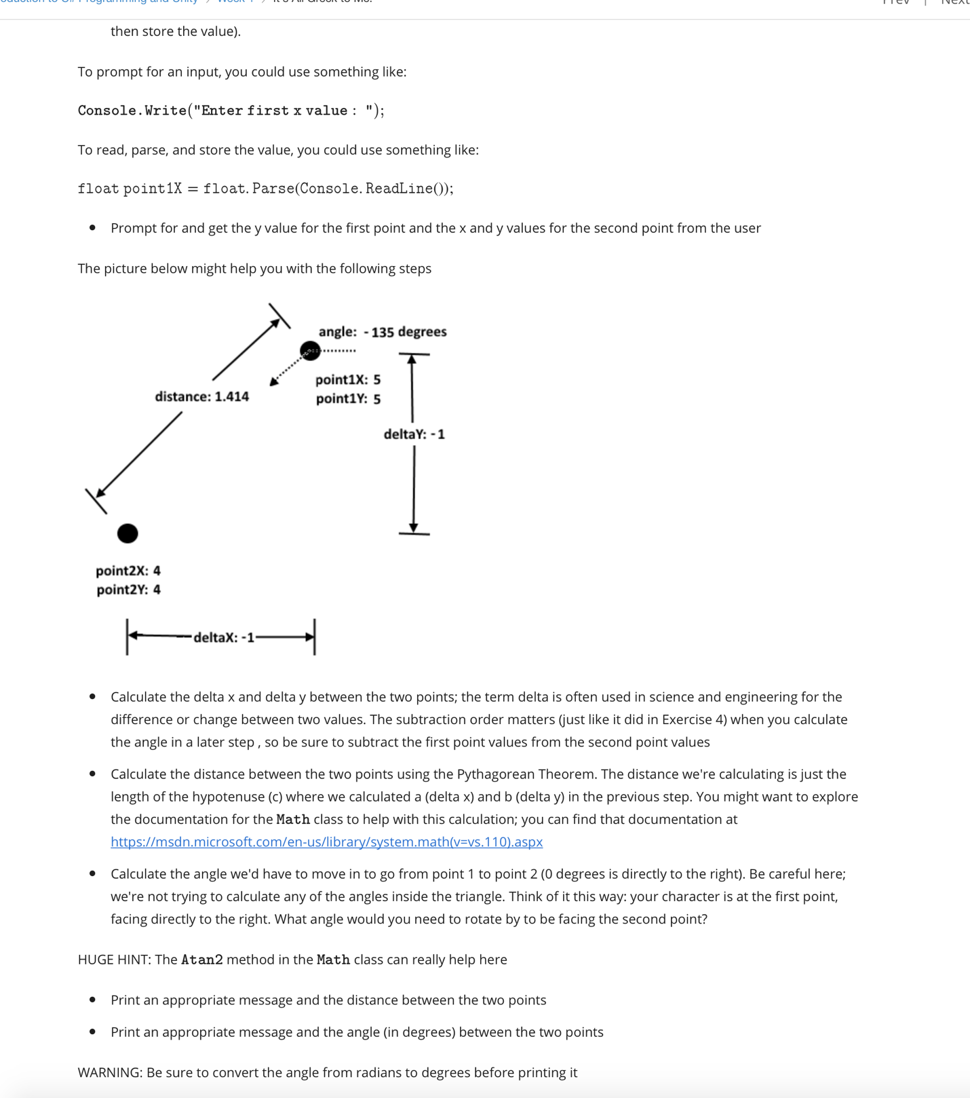

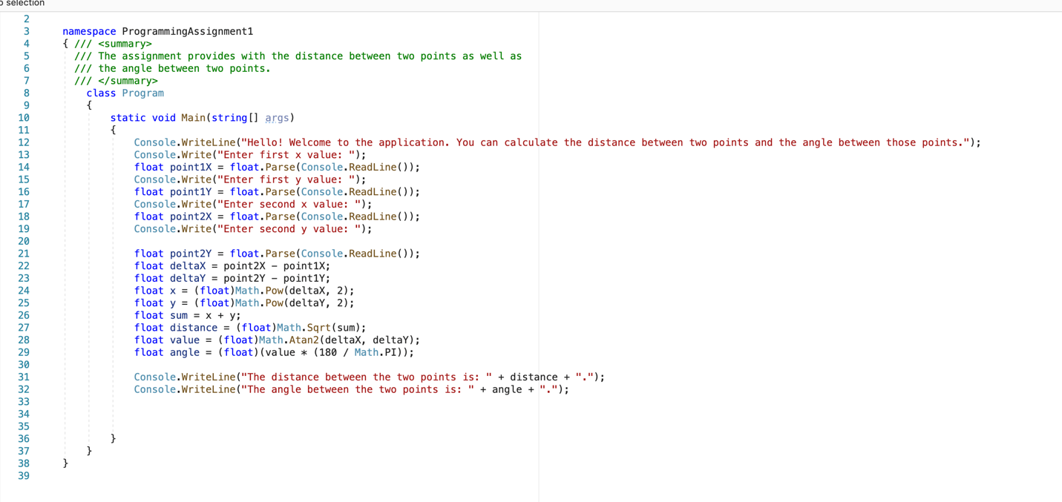

**Week 2: -**

*Intro to Classes and Objects*

* Objects have state (characteristics of the object) e.g. ship in a game, that can have a velocity etc, states are stored in fields and are accessed through properties (A get **property** accessor is used to return the **property** value, and a set accessor is used to assign a new value.)
* Objects have behavior (what we can do to the object or can tell the object to do itself), accessed through methods
* Objects have identity (so we can distinguish one object from another, unique memory address of each object), identity created when we create a new object (instantiation)
* E.g. playing card (state: rank, suit, face up or not; behavior: flip over)
* Class is a template for creating objects
* Class defines fields, properties, behaviors of every object in the class
* Object is an actual instance of the class in memory
* Each object stores its own state

*Using a Class: Constructor*

* *We can instantiate an object within the string args[] method.*
* *Remember!! that string args[] is a static method , and so we just cant use classname.method like Math.cos(), with normal classes. Or normal classes are not static, we will have to instantiate/create a new object and then use object.method. Instantiate using this (Deck deck = new Deck();) and then to use methods, do deck.Print(). Deck class here is not built-in in C#, we have to create it separately and then upload it, to use it in the main method.* To create a new class, in the Solution Explorer, right-click Name of our file-> Add -> Class... Set the Name to **whatever we like** and click Add. Create your class and save it and then add it in your main program file with main() method, using the Solution Explorer again.

*Using a Class: Properties*

* A property does not have () in the end.
* For example, if a class called Deck has a field named Empty which is a boolean… we can access it as a property by a ‘get’ accessor…No mutator or ‘set’ is possible as this is a Boolean…. So in string args[], we can write bool result = deck.Empty; (see that we have no () after empty, while we had () in deck.Print() which was not a property, but was a method) after creating a deck object above. We can display the results by writing Console.WriteLine(result); //or don’t use a variable result but write directly Console.WriteLine(deck.Empty);

Example of set property:

* class Person
* {
* private string name; // field
* public string Name // property
* {
* get { return name; }
* set { name = value; }
* }
* }
* class Program
* {
* static void Main(string[] args)
* {
* Person myObj = new Person();
* myObj.Name = "Liam";
* Console.WriteLine(myObj.Name);
* }
* }

*Using a Class: Methods*

* *Eg. To shuffle the deck… do deck.shuffle() and then deck.Print() to shuffle and then print the results*
* *Methods can have parameters too. For e.g. if the method from class is public void Cut (int location) [the location at which to cut the deck]… When we call such a method, we will have to place an argument in place of the parameter….So, write something like this in args[] main method: deck.Cut(26);*
* *Sometimes, some methods can return an object as well. E.g. public Card TakeTopCard()….. we can call this in main method with something like this: deck.TakeTopCard() [this will just remove the top most card from the deck] or we can use the object of this method to give us different types of information that we might need…e.g…..Card x = deck.TakeTopCard(); …..and then Console.WriteLine(x.rank + “ “ + x.suit) rank and suit are properties that we can find for this particular card object. Rank and Suit can be accessed because we uploaded another Card class file that had these properties*
* *Example Exercise:*

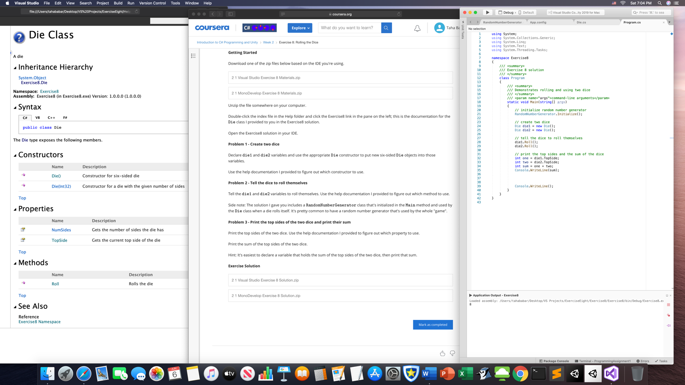

* *Example Exercise*

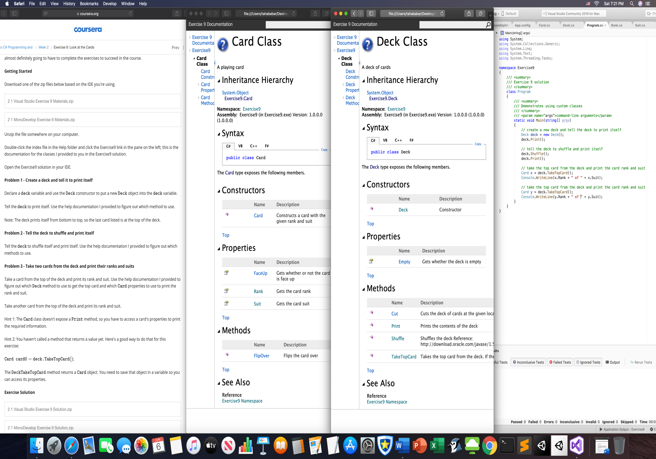

*Classes and Objects in Unity*

* The scripts that we write in Unity are classes.
* And when we attach a script as a component to a game object in a Unity scene,

then we get an instance of the class, or an object is attached to that game object.

*Programming Assignment 2*

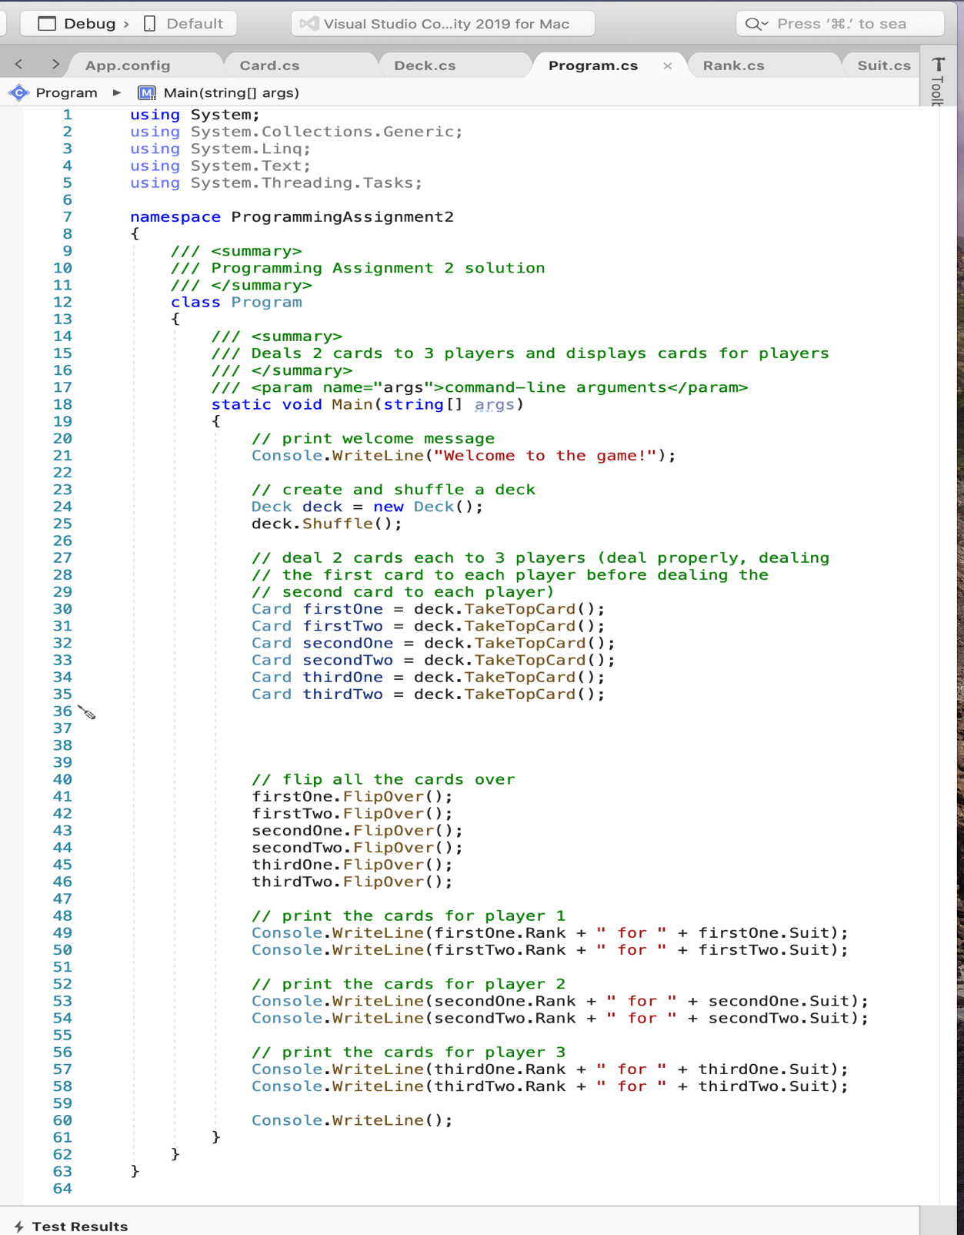

**Week 3**

*Sprites and Game Objects*

* Sprite is a graphical asset… It can be single or multiple frames (sprite strips or sprite sheets)
* Game object is an entity in a unity scene
* For sprites, go under Project, and create a new folder called sprites
* To add an image to your sprite folder, drag the picture to the sprite folder
* To add spite/image in a scene, drag that image from the sprite folder and drop it in the scene i.e. scene0 in the hierarchy section. After saving, you will see the image in the game window as well as in the scene window.
* Click on the image and then open the inspector tab, to edit the image or even the camera size. i.e. reduce the size of camera to increase the size of our image, without affecting the image’s pixels.

*Unity’s Component System*

* Scripts are components too
* We can add scripts as well to objects. To do this, create a normal script file, add print(“something”); in it. Attach the script file to the object in hierarchy tab, and then play the game. We will see the message in the console area.

**We can debug a Unity script by using breakpoints and “Attach to Unity” when the script is opened…**

Changing the scale of a game object without using inspector’s scale component:

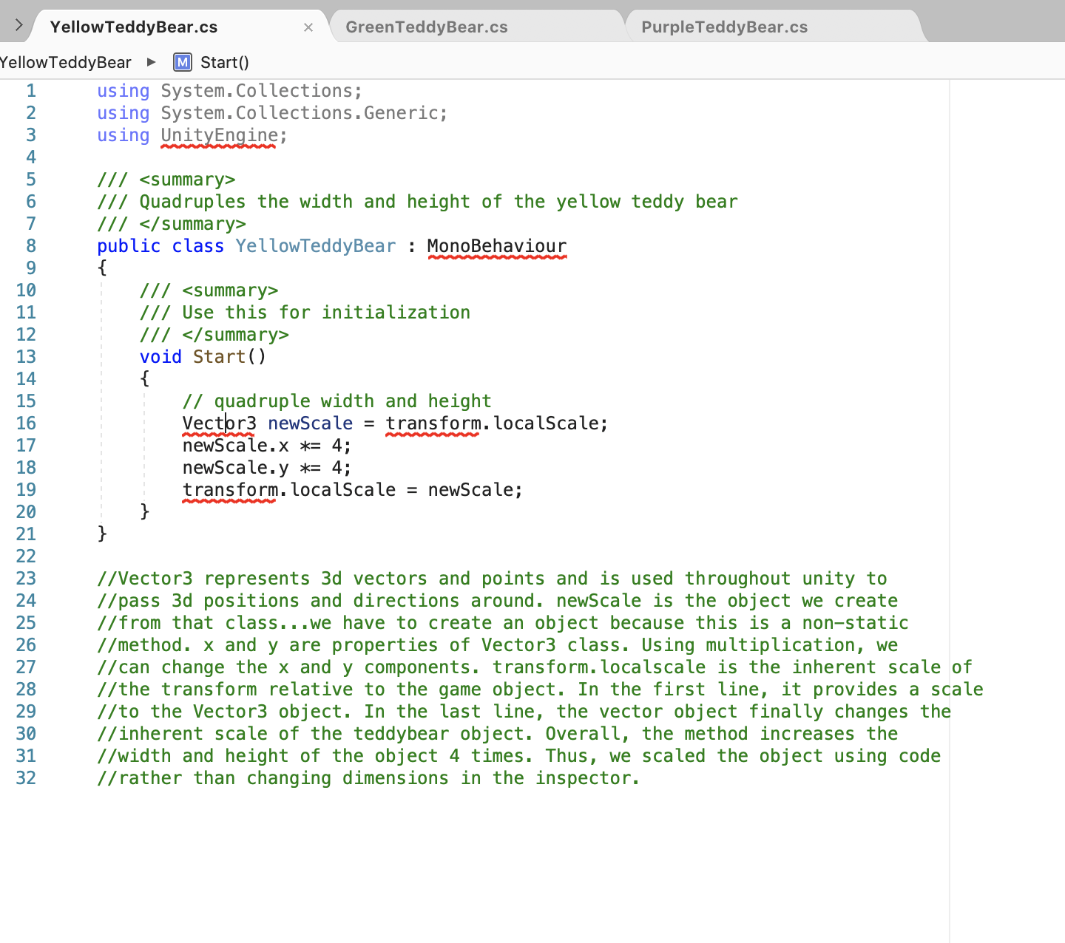

*2D Physics*

* Add physics component in inspector area and select rigidbody 2d. If you know click play, the object will move down because of gravity due to physics. To avoid it, go to edit,project settings, physics 2d, y =0.
* Check API documentation to find physics things such as rigidbody 2d, and add physics related things in new scripts to move our objects.
* Don’t forget to attach the script to the object.

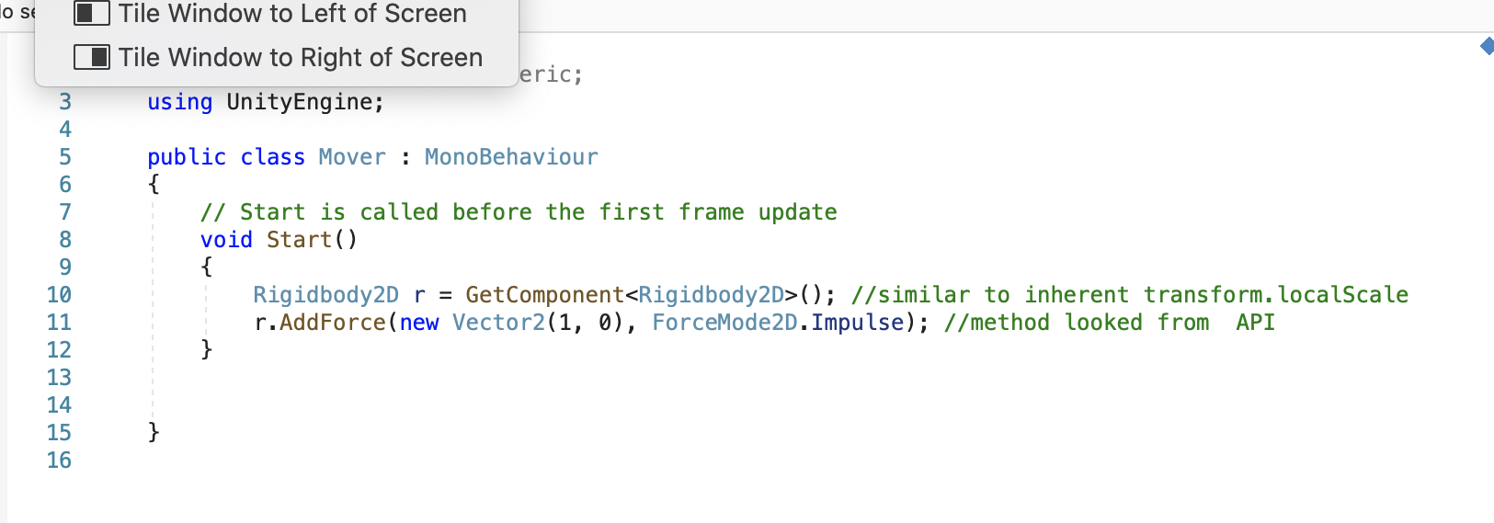

*We can also use transform.position to move the objects. The code picture is in if statements area.*

*Colliders and Physics Materials*

* Collision Detection is detecting collisions between game objects-> If both game objects have 2d colliders, the physics 2d engine automatically does collision detection
* Collision Resolution is doing something based on the face that a collision has been detected->2d physics materials for the game object colliders determine how the physics 2d engine resolves the collision->we ca also do additional collision resolution ourselves
* Add component Physics 2d->Box component->edit collider (make the edges of on the screen match the edges of the object)->unclick edit collider
* Ass component (on the camera object) -> Physics2d->Edge collider 2d->edit collider..drag the green dot in the center and move it to each corner of the edge one by one…and make a rectangle of green lines on the edges of the camera.
* You can change the Mover script to move the object randomly: -

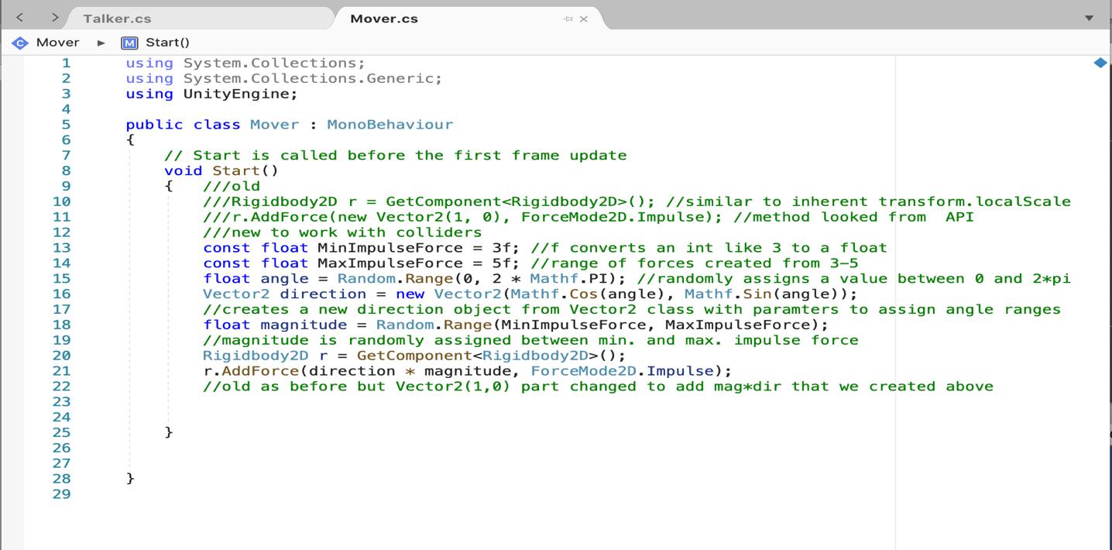

-To make your objects bouncy, create a new folder called materials in the project section. Right click -> click physics 2d -> name it “TeddyBearMaterial” for our teddy bear object..and create another physics 2d material and name it “EdgeMaterial” for our camera edges. Click on each of them and see them in inspector. Change their friction to 0 and their bounciness to 1. Then click on Teddy Bear from hierarchy. Open the inspector. Drag the “TeddyBearMaterial” from Project area to the Material box in EdgeCollider2d component in the inspector area. Do the same but with EdgeMaterial and Camera object’s EdgeCollider’s Material box.

*Prefabs*

* A prefab is a prefabricated game object, a game object we have configured the way we want, then saved as a prefab.
* Because of prefabs, we can easily add instances of the prefab to a scene in the editor and can easily add instances of the prefab to a scene from a script
* Create a folder called prefabs in the project area. Drag the teddybear object from the hierarchy area and drop in the prefabs folder in the project area. Now, we will have the teddybear instance in our prefab folder with all the already declared components in our original teddybear object. Simply drag that prefab from the prefab folder and drop that within our scene, to multiply/add more… teddybear objects in our scene. Also, edit directly the prefab object, to bring changes to all the objects.
* To add a script to all of the prefabs, drag the script on one of prefabs/objects in hierarchy folder. Then click that prefab. Open inspector. Click the drop down which says Overrides…and then click apply all.. The script now applies to all the prefabs.

*Booleans*

* True or False ….represented by *bool*
* Helps in making decisions in our code
* Logical operators: && , ||, !
* Relational operators: ==,!=,<,<=,>,>=

*If Statements*

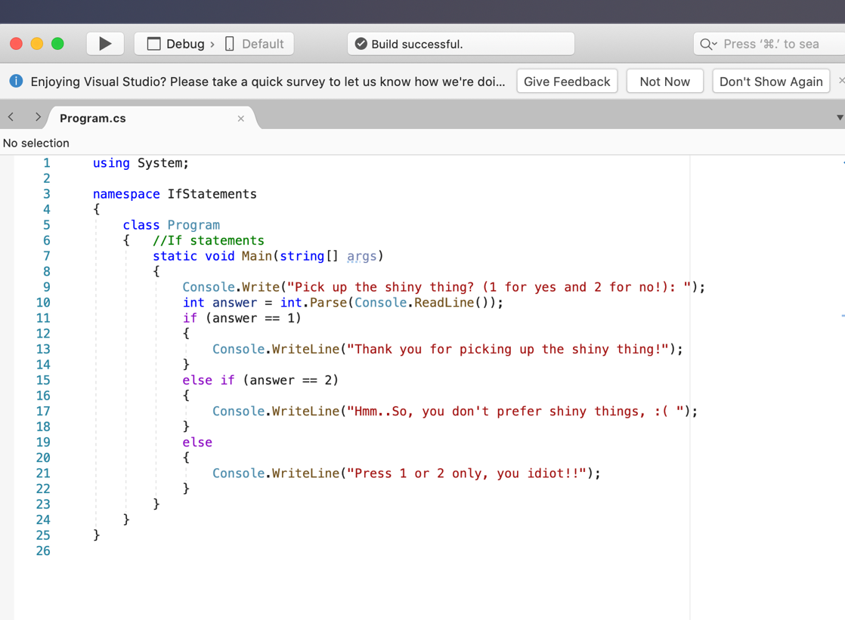

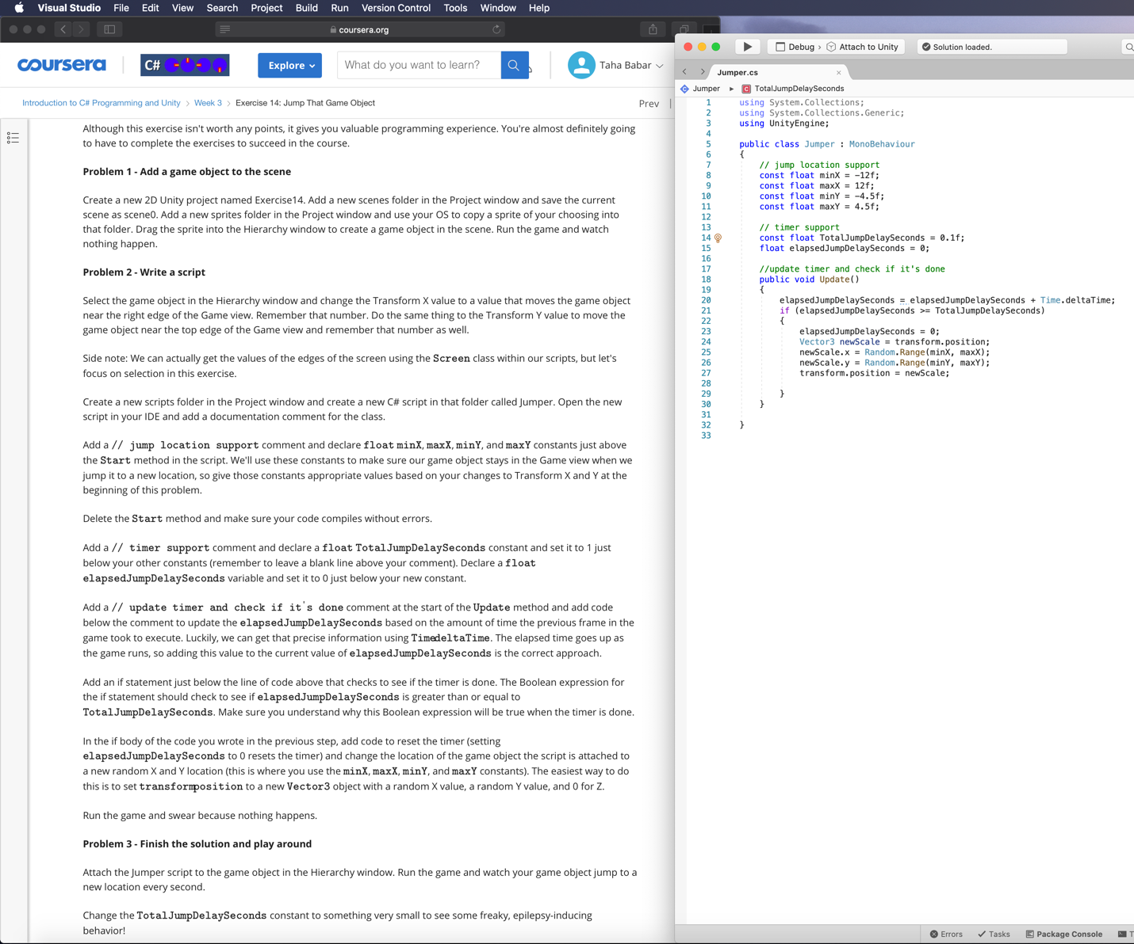

*Switch Statements*

* 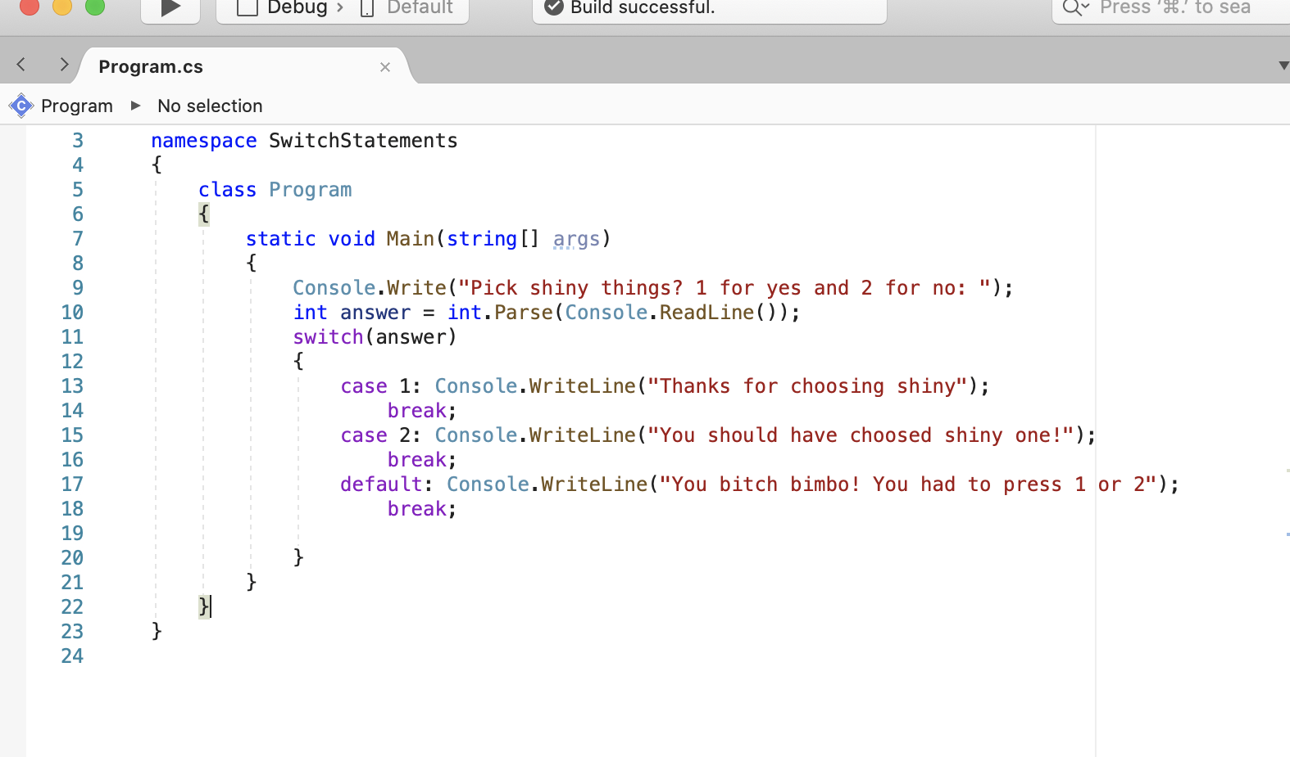

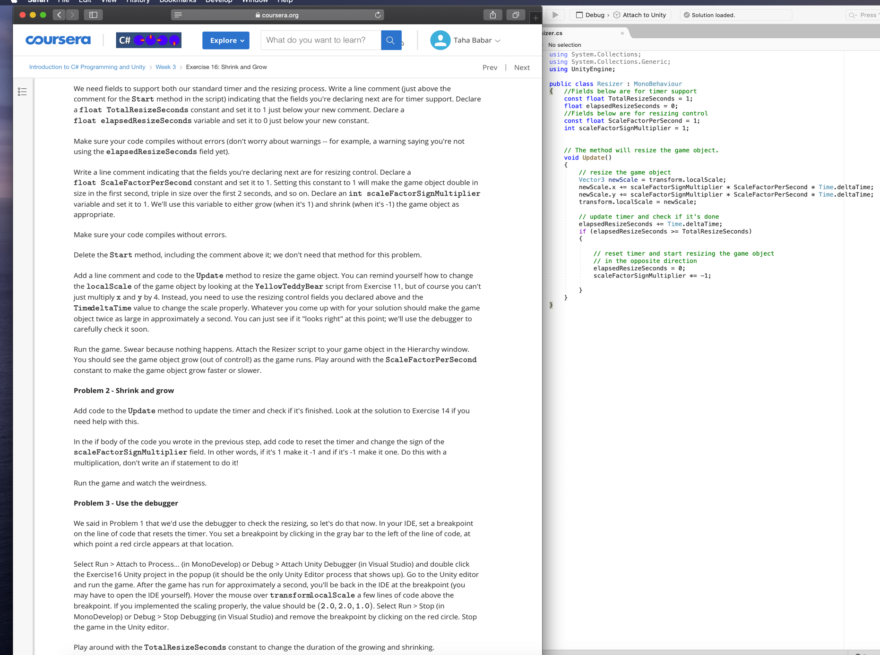

*Timers*

* if we have levels in our game that have a time limit,

we can use a timer to determine when the level has ended.

We can use a timer to decide when to spawn new objects into the game world.

We can use a timer if our game objects have

a limited lifespan so this is really a death timer.

We can decide when to destroy that game object

and we might even decide if we're going to regularly or

periodically increase the difficulty of our game

at particular time hacks

* To implement timer on our camera object, we will need two different scripts. Read the scripts…pretty self-explanatory

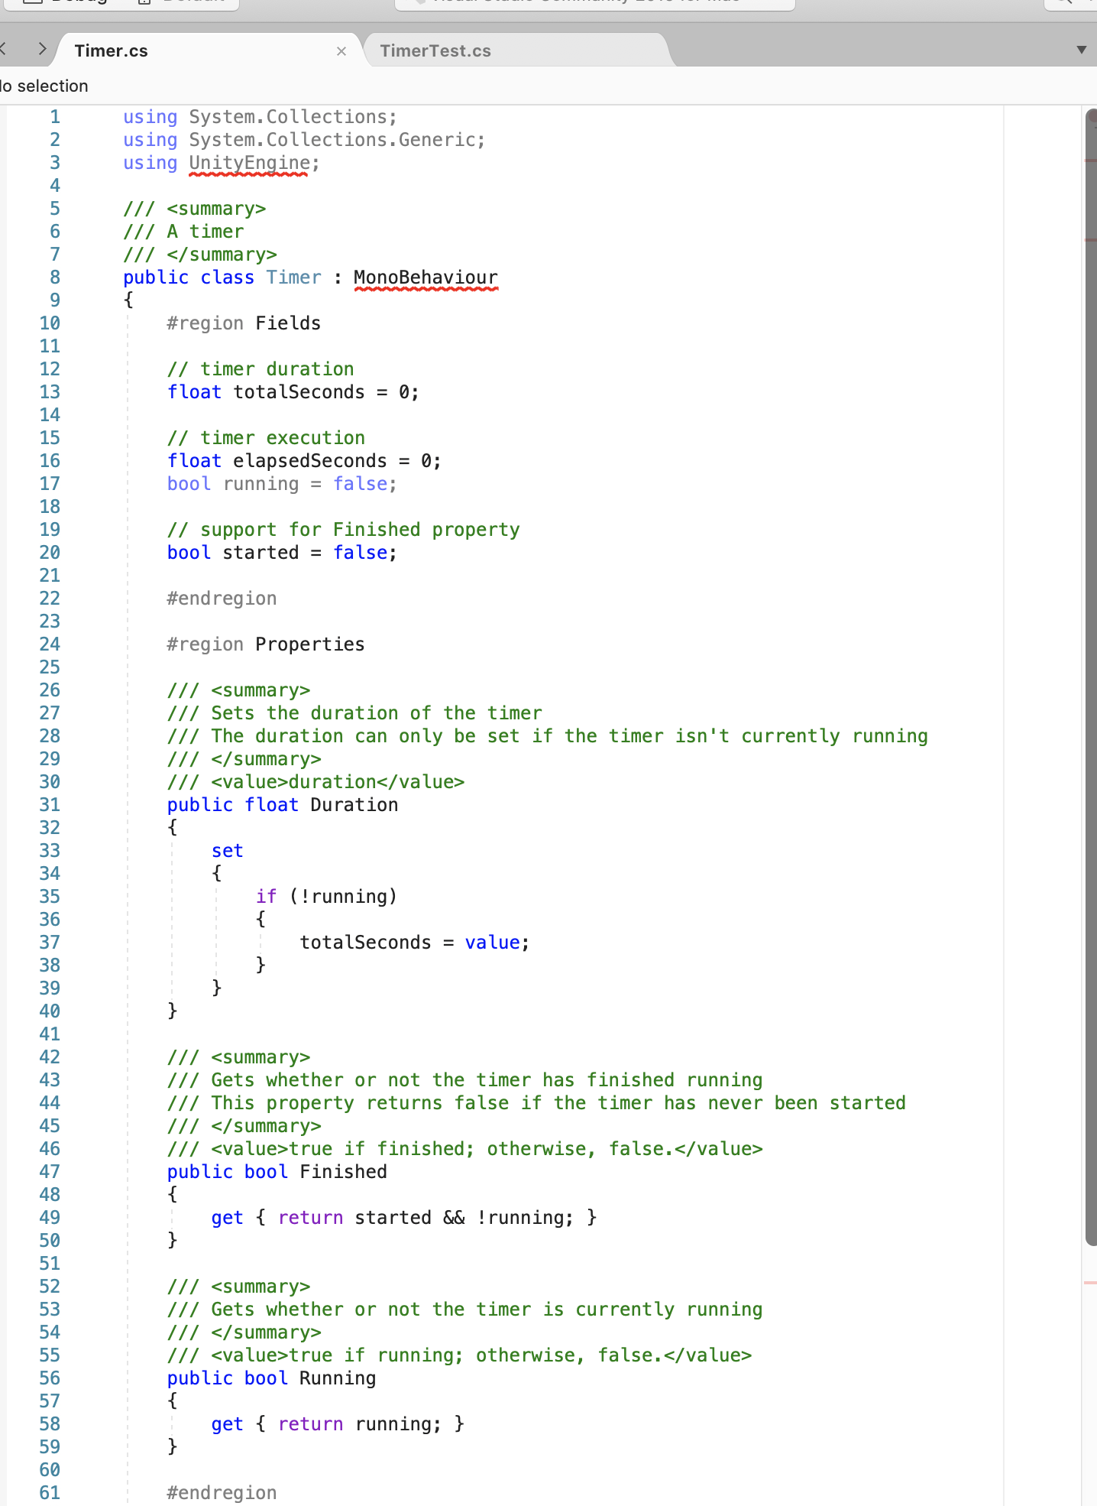

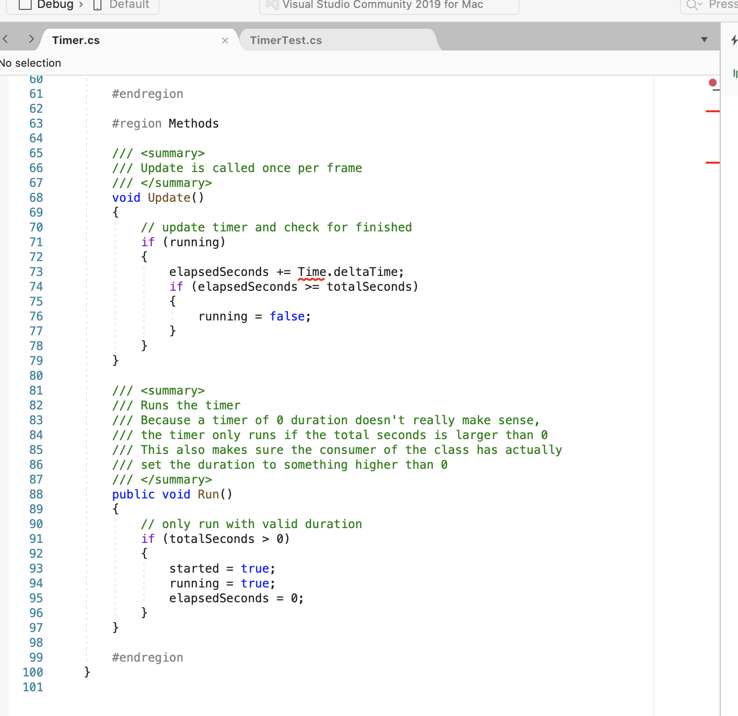

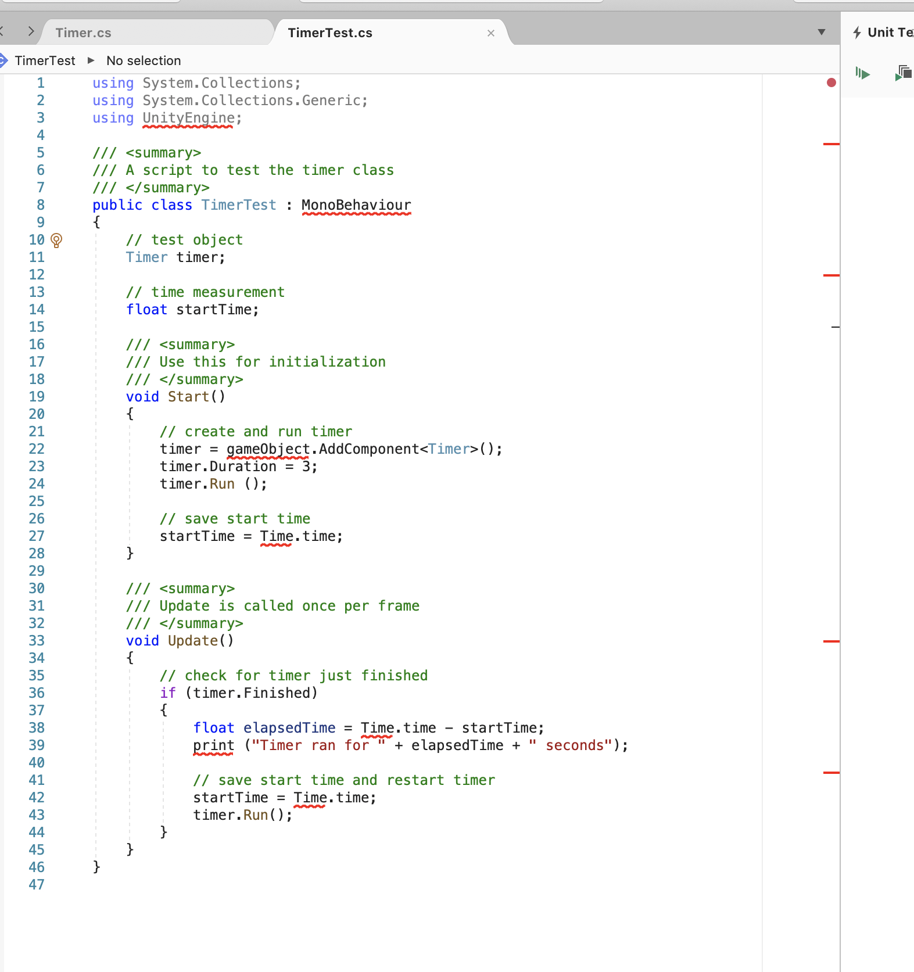

*Last 2 videos of wk3 left, along with Assignment 3*

**Week 4: -**

*Mouse Location Processing*

* Add a script named “character” and attach it to your prefab… Then apply all in the hierarchy window of that prefab.
* Go to API Documentation…Type Input class…there is an input.getmouseposition
* The method gives us mouse position in screen form…we need to change those coordinates in a world form
* In the script, everything needs to stay the same…Just change the update method to this.
* First line creates a Vector3 object, because input.mouseposition is a Vector3. It creates an object from Input class. The next 2 methods convert it in world from from screen coordinates. The last line changes the position of the object to the position whereever the mouse is hovered.

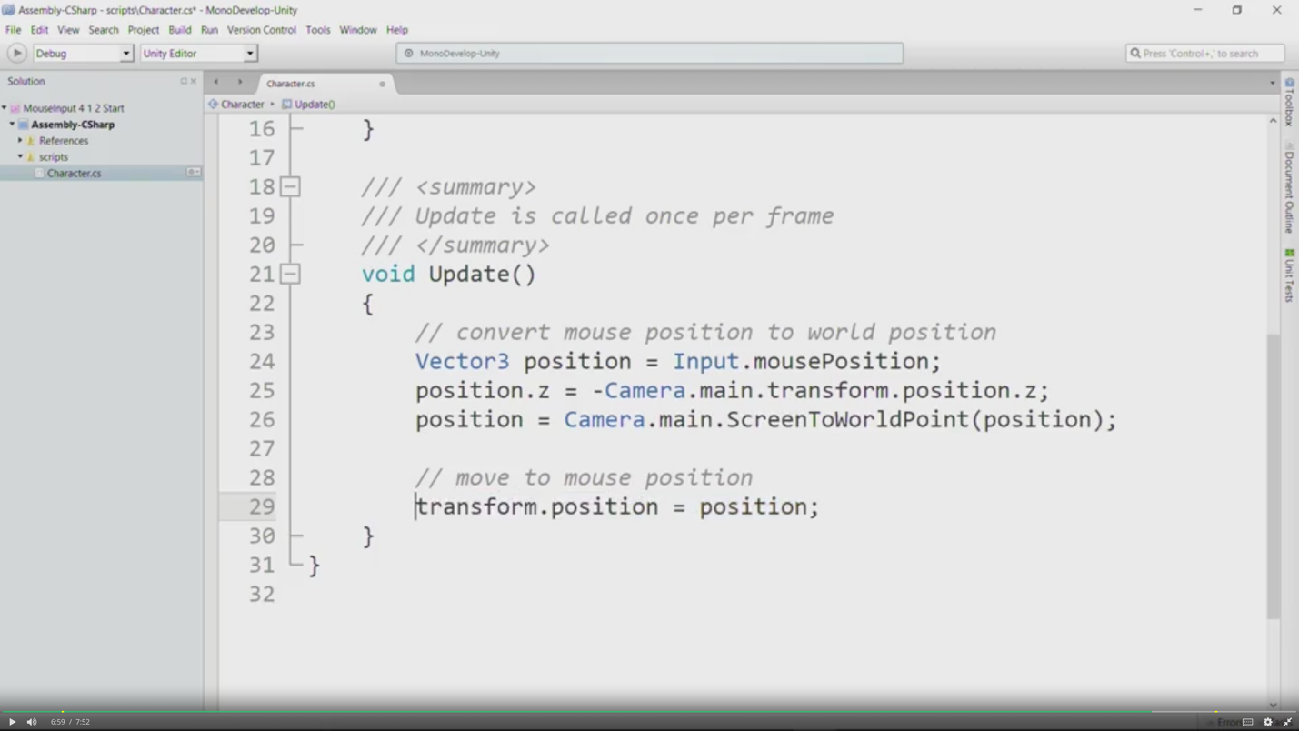

*Working for the Clampdown*

* *To make sure that the object stays within the screen, even when mouse leaves the screen… we do clampdown..*
* *Crete 2 more scripts … ScreenUtils and GameInitializer..also edit character script. Attach screenutils to the character object and gameinitilizer to the camera object.*

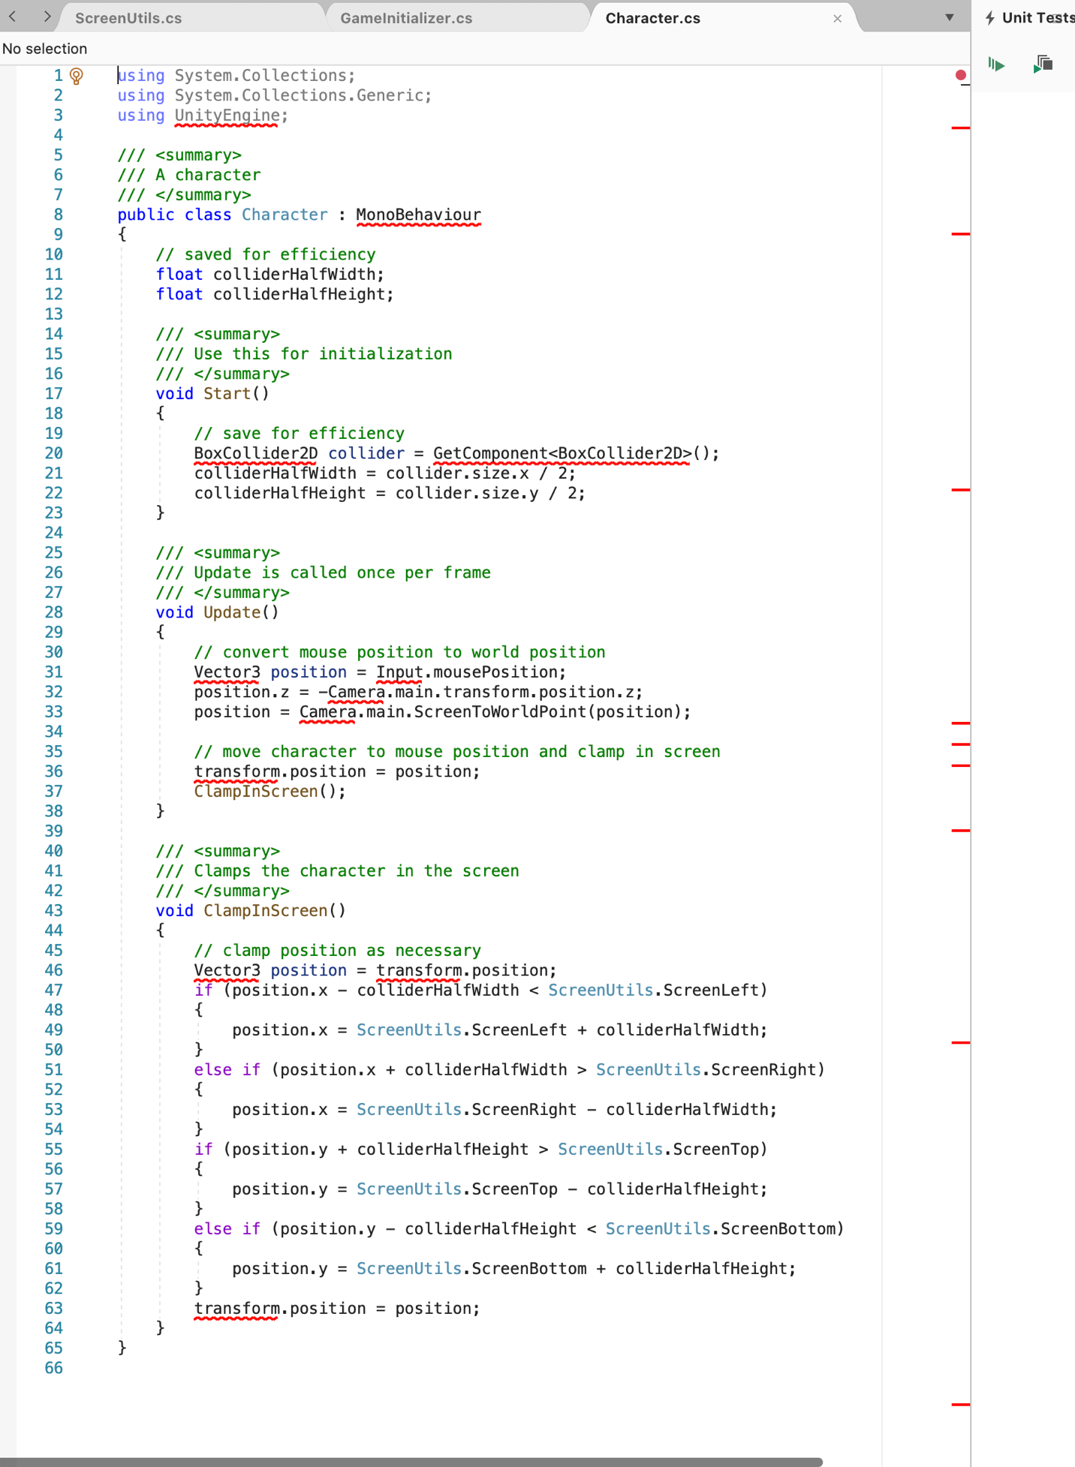

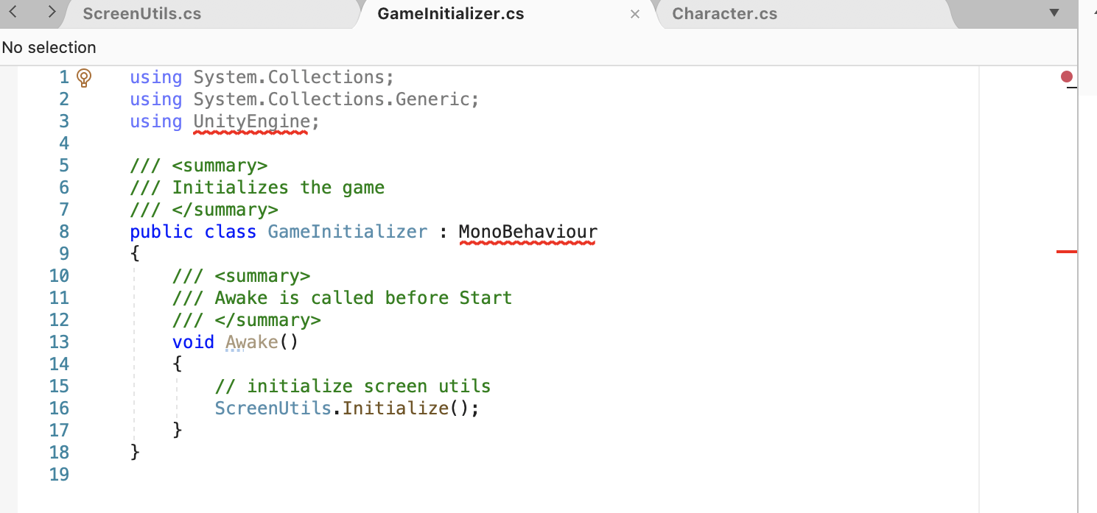

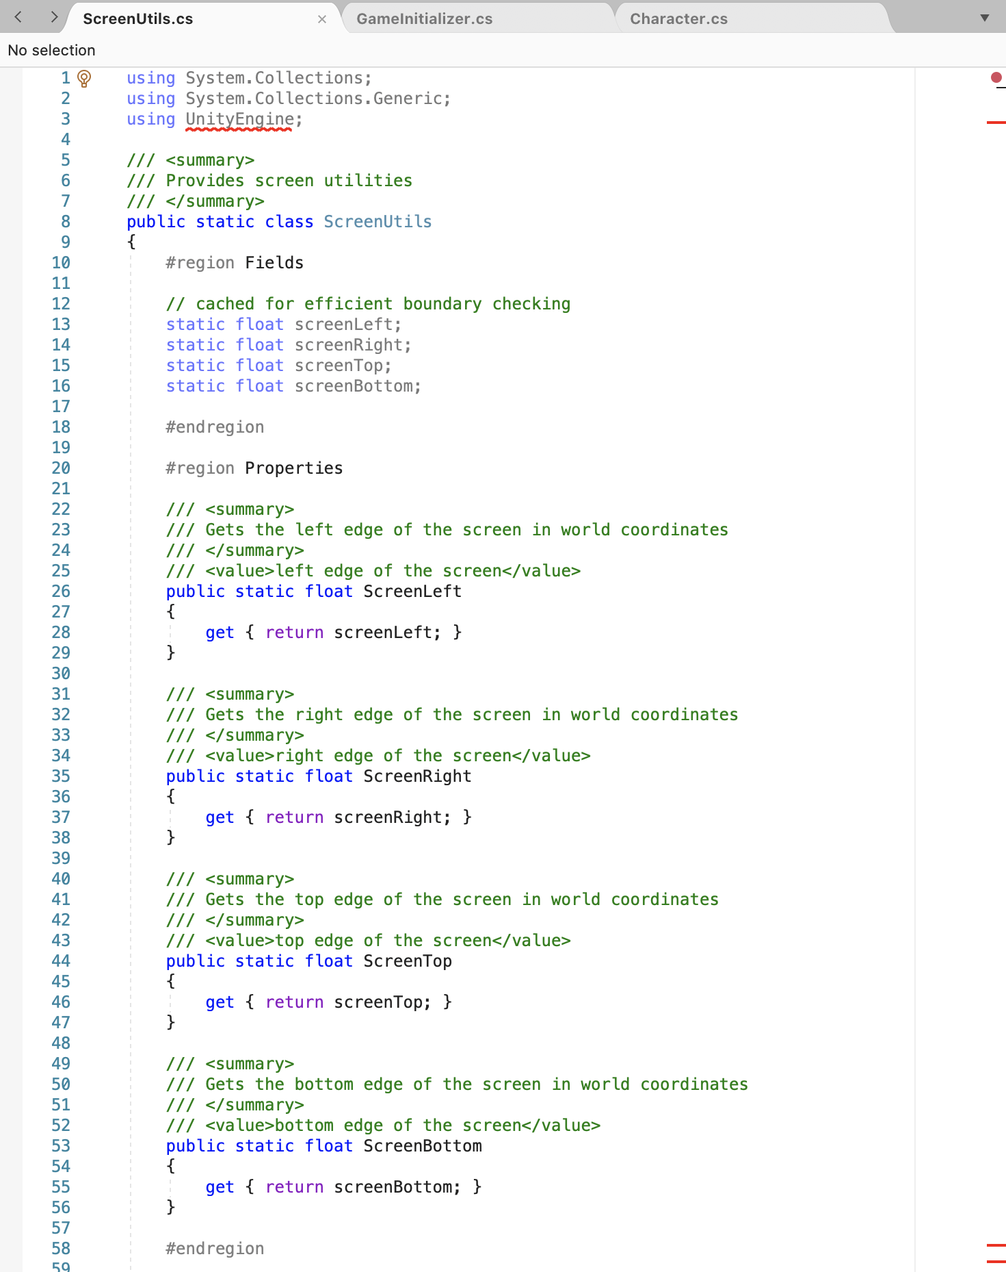

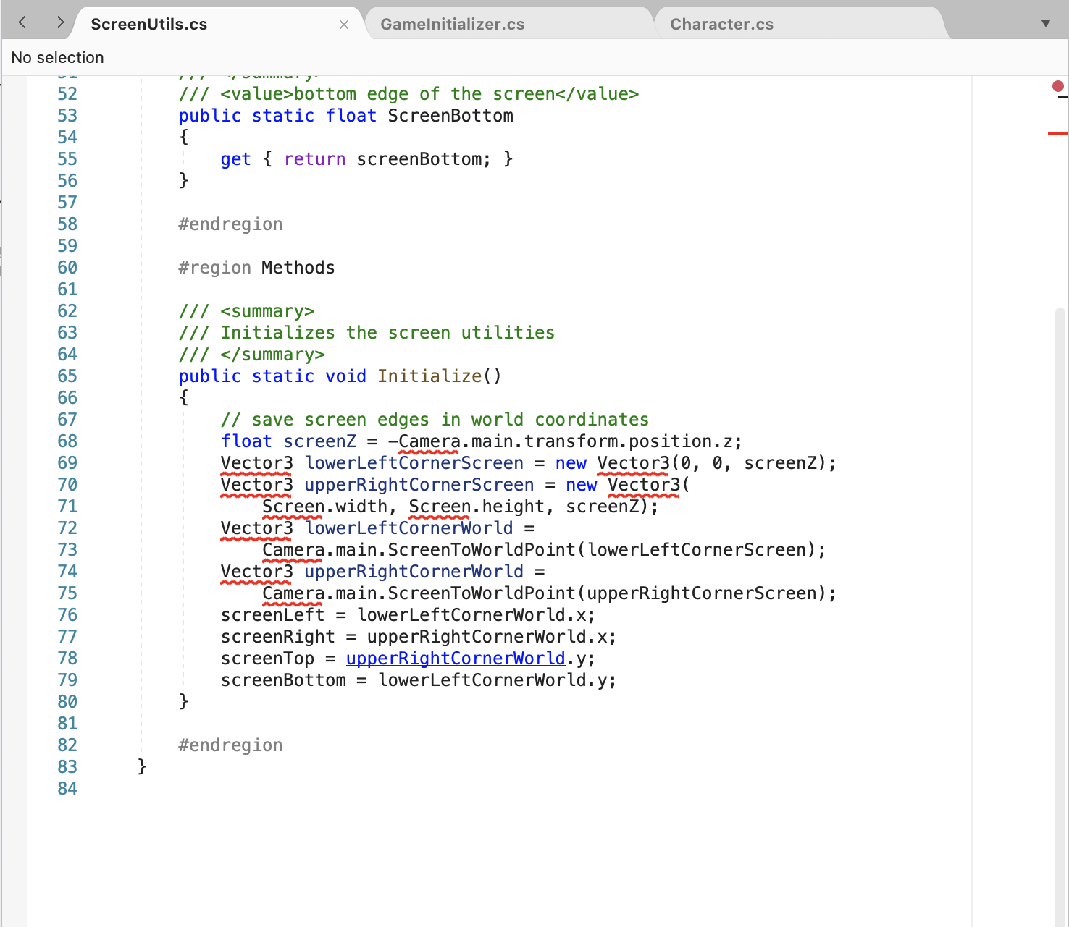

*Mouse Button Processing*

* + We will consider a 3-button mouse
  + New script called CharacterChanger..and attached to main camera object
  + From api, we need Input.GetMouseButtonDown method
  + SerializeField makes sure that..that specific character prefab displays in the hierarchy window when operation is being done on it
  + Quaternion.identity means the rotation is 0.
  + This code is for 4 different characters. When we mouse click left, the first character is destroyed and randomly other character comes…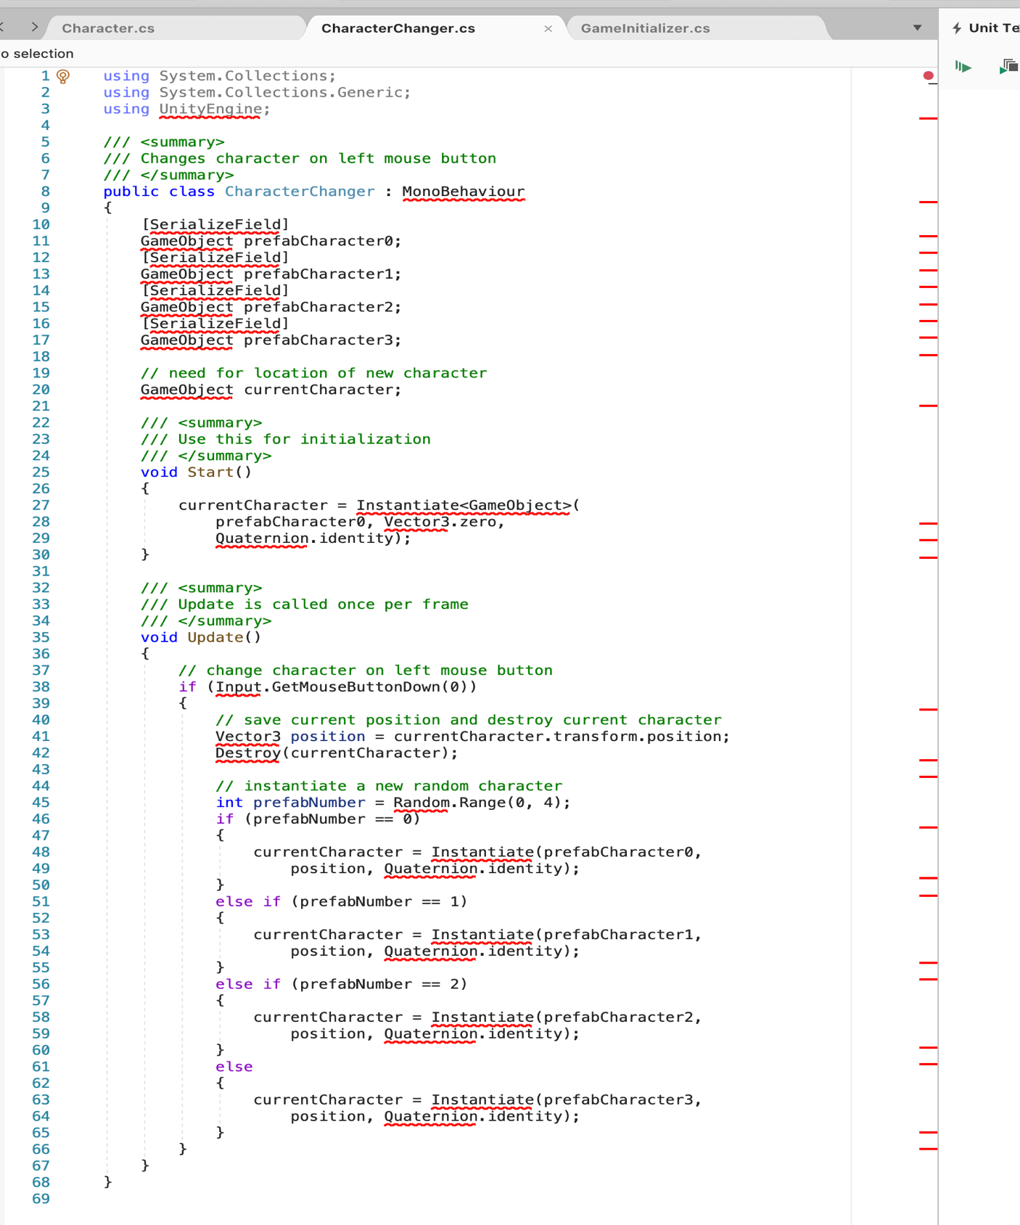

*The Input Manager*

* It manages input.
* It lets us map named input axes to particular inputs.
* So, for example, we can name an input axis horizontal and
* map it to the A and D keys for left and right to move horizontally.
* It also lets us check for player input from within our script,
* and that's really helpful because we react to player input in our games all the time.
* Another thing the input manager lets us do is it actually lets players
* remap the input so if they don't like using A and D for left and right,
* if they would prefer using W and S for left and right, then they can do that.
* Go to edit->Project settings->Input….Go to inspector..Click Axes..
* You can see many axes there…Negative and positive button and their alts move our objects to left or right. Snap should be clicked tick…Type should be key and mouse only as our most work will be with them….
* File->Build settings->Click ass open scenes->Build and run->save it in a new folder called “Build”->File name should be InputManager->Click save->Click Play in the popup window that comes up
* When doing mouse and keyboard functions for joysticks and gamepads, use horizontal and vertical axes at the bottom half of input manager |(as there are 2-2 horizontal n vertical axes each in the input manager)

*Mouse Button Processing -Part 2*

* Go to edit->Project settings->Input….Go to inspector..Click Axes..
* To add one, add one in size (i.e. if 18 was written before, write 19 now)
* A new cancel button comes in the end…click it..chnage its name to ChangeCharacter..Positive button will be mouse 0.Remove everything from alt positive button
* Use input.getaxis method..if it is greater than 0, it means left button on mouse was clicked
* Change CharacterChanger.cs script to look like this: -

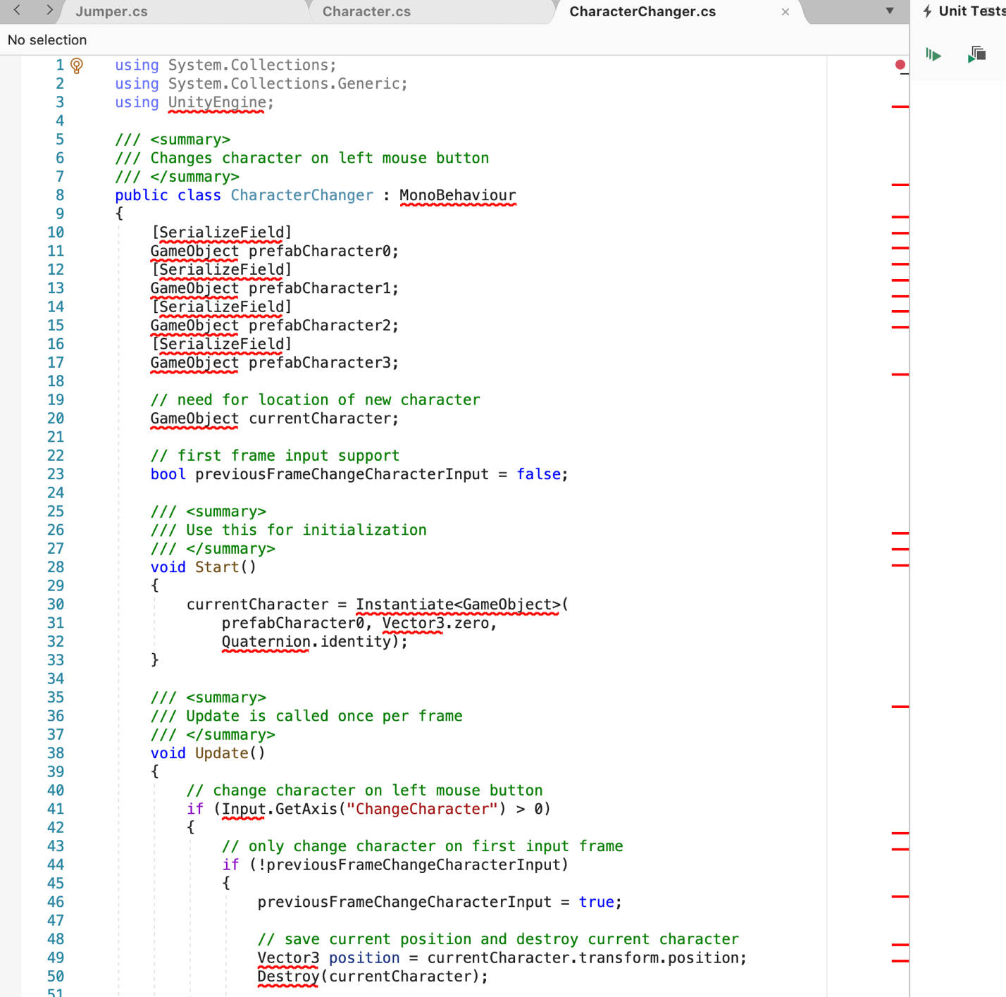

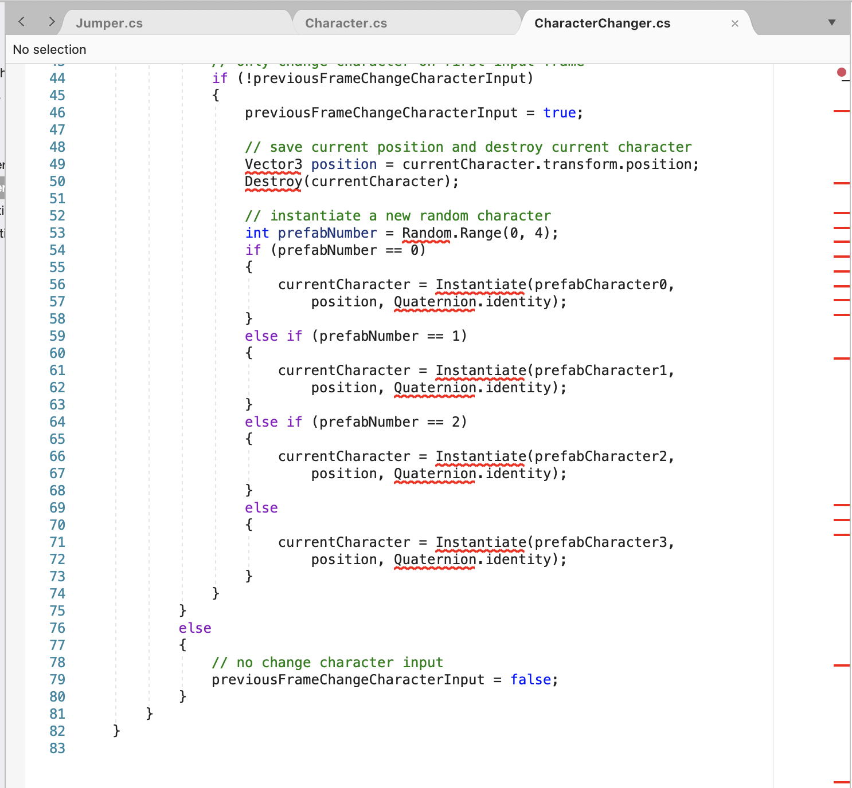

*Keyboard Processing*

* Add a script called Driver and add this code to move object horizontally and vertically as needed, using the keyboard.
* In the input manager, for horizontal and vertical alt buttons, assign your prefered keys
* - Add the script to your teddybear project

